# Premier University

**Department of Computer Science & Engineering**

**3rd Semester Class Test, Fall 2023**

**Course Title: Object Oriented Programming (Sec - A)**

**Course Code: CSE - 1115**

**Time: 25 min Marks: 20**

1. Implement the following scenario for inheritance:

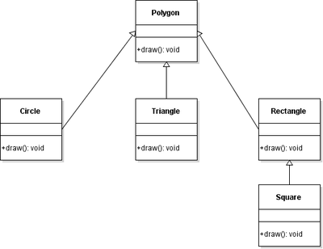

**Figure 1**